# Microservices with Spring Boot #10 || Logging in Spring Boot App || Different levels of loggging

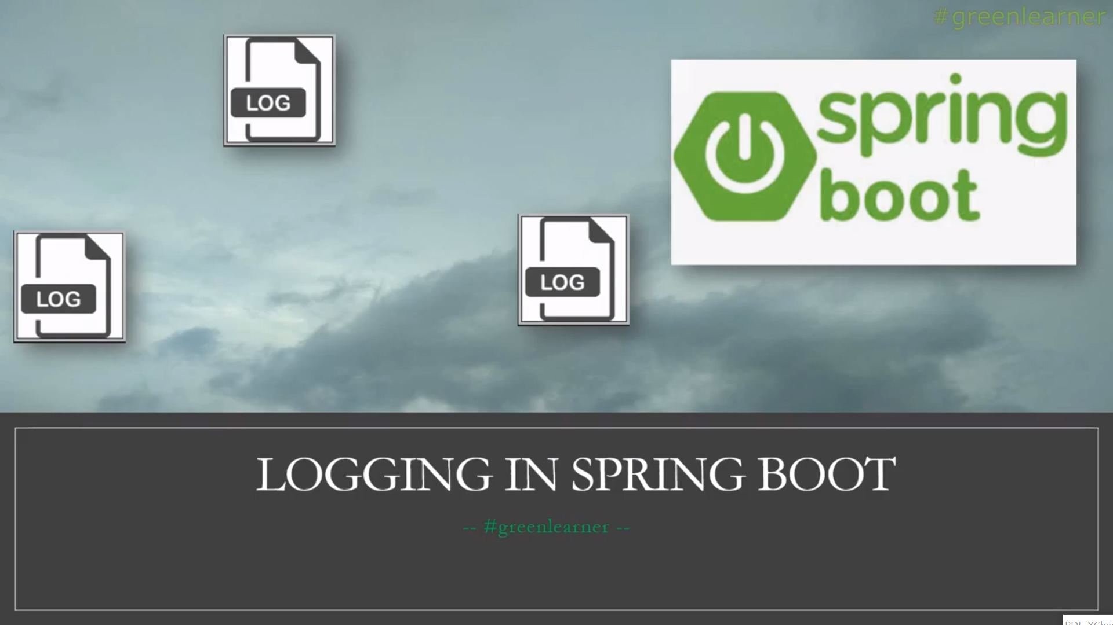

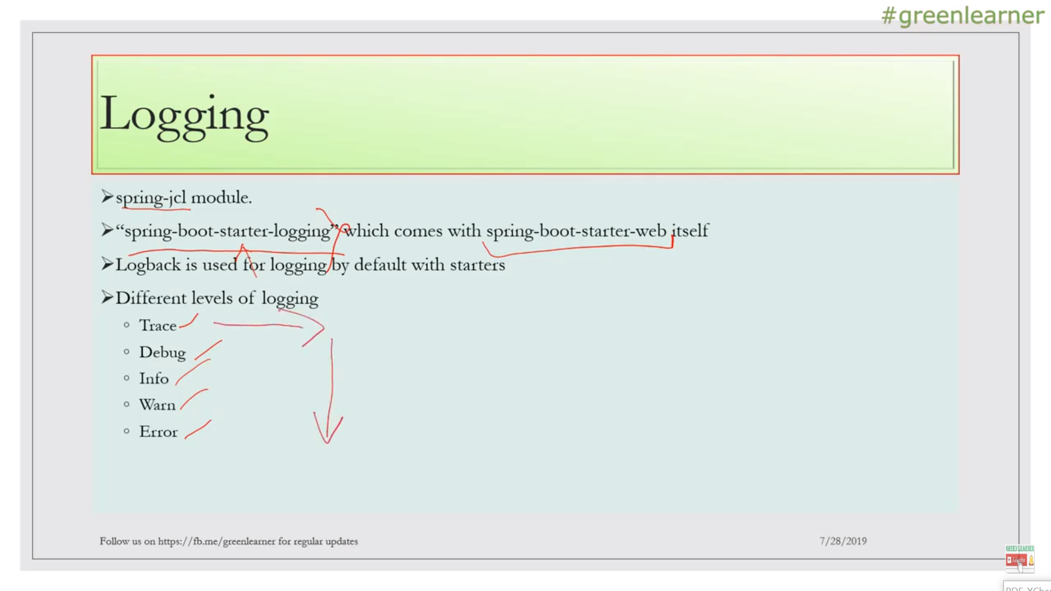

Logger adding into **usermanagementapp**

**TRACE and DEBUG by default won’t be enable**

**So when we enter URL for web-service:** <http://localhost:8082/logs>

Logger logger= LoggerFactory.*getLogger*(UserController.class);

@GetMapping("/logs")  
public String logs()  
{  
 logger.trace("A TRACE MESSAGE");  
 logger.info("An INFO Message");  
 logger.debug("A DEBUG Message");  
 logger.error("An ERROR Message");  
 logger.warn("A WARN Message");  
 return "Hey buddy see the console for different level of logs";  
}

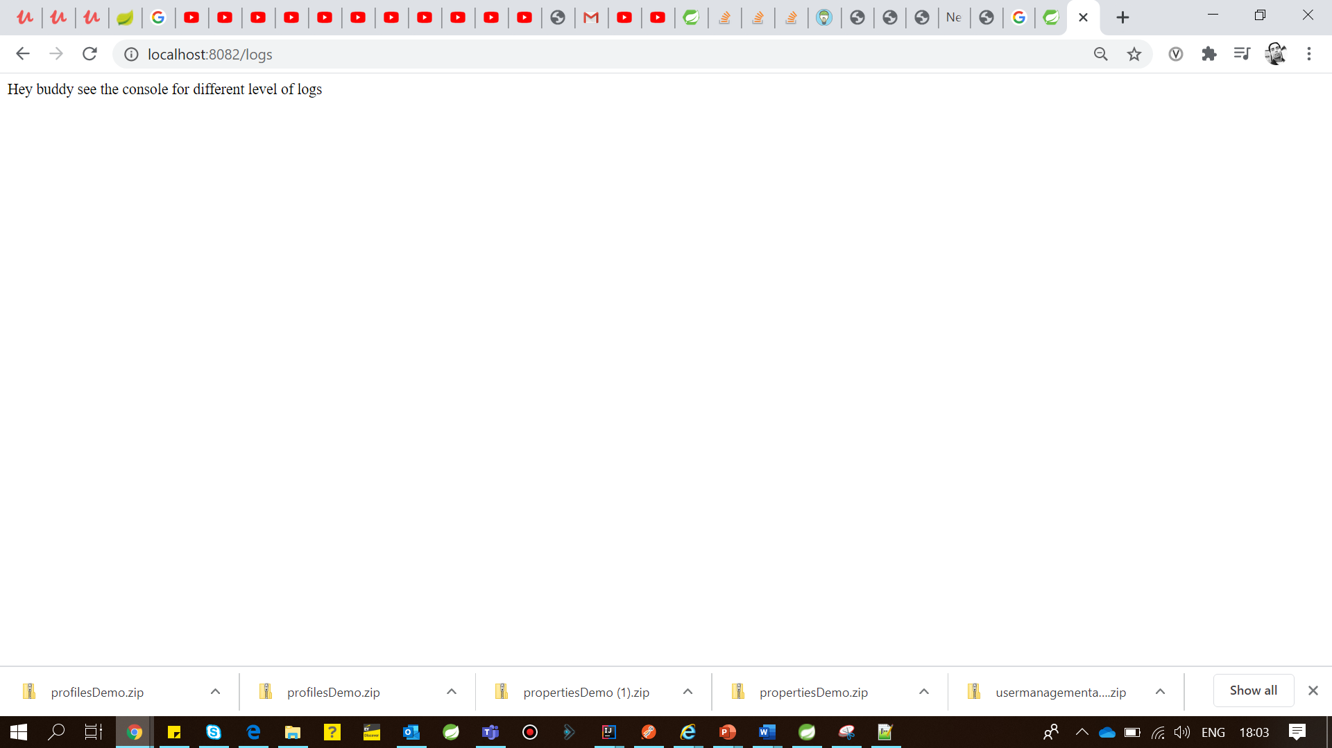

**Console:-**

2020-07-06 17:59:41.877 INFO 28420 --- [ restartedMain] o.s.b.w.embedded.tomcat.TomcatWebServer : Tomcat started on port(s): 8082 (http) with context path ''

2020-07-06 17:59:41.880 INFO 28420 --- [ restartedMain] d.s.w.p.DocumentationPluginsBootstrapper : Context refreshed

2020-07-06 17:59:41.940 INFO 28420 --- [ restartedMain] d.s.w.p.DocumentationPluginsBootstrapper : Found 1 custom documentation plugin(s)

2020-07-06 17:59:42.055 INFO 28420 --- [ restartedMain] s.d.s.w.s.ApiListingReferenceScanner : Scanning for api listing references

2020-07-06 17:59:42.475 INFO 28420 --- [ restartedMain] c.a.l.u.UsermanagementappApplication : Started UsermanagementappApplication in 10.081 seconds (JVM running for 14.075)

2020-07-06 18:01:12.132 INFO 28420 --- [nio-8082-exec-1] o.a.c.c.C.[Tomcat].[localhost].[/] : Initializing Spring DispatcherServlet 'dispatcherServlet'

2020-07-06 18:01:12.132 INFO 28420 --- [nio-8082-exec-1] o.s.web.servlet.DispatcherServlet : Initializing Servlet 'dispatcherServlet'

2020-07-06 18:01:12.162 INFO 28420 --- [nio-8082-exec-1] o.s.web.servlet.DispatcherServlet : Completed initialization in 29 ms

2020-07-06 18:01:12.244 INFO 28420 --- [nio-8082-exec-1] c.a.l.u.controller.UserController : An INFO Message

2020-07-06 18:01:12.245 ERROR 28420 --- [nio-8082-exec-1] c.a.l.u.controller.UserController : An ERROR Message

2020-07-06 18:01:12.245 WARN 28420 --- [nio-8082-exec-1] c.a.l.u.controller.UserController : A WARN Message

**If I want to enable rest 2 Debug and Trace then need to set in application.properties:-**

logging:  
 level:  
 ROOT: DEBUG  
server:  
 port: 8082

<http://localhost:8082/logs>

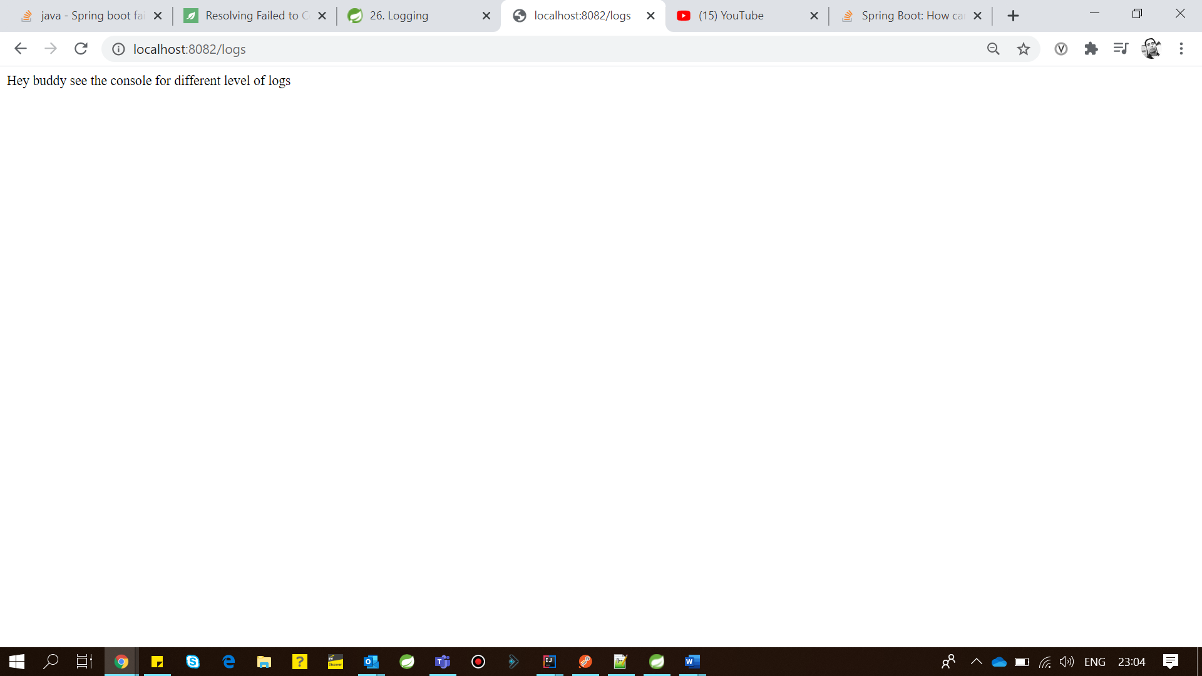

**2020-07-06 23:02:35.876 DEBUG 16372 --- [nio-8082-exec-3] pertySourcedRequestMappingHandlerMapping : looking up handler for path: /logs**

**2020-07-06 23:02:35.880 DEBUG 16372 --- [nio-8082-exec-3] s.w.s.m.m.a.RequestMappingHandlerMapping : Mapped to com.always.learner.usermanagementapp.controller.UserController#logs()**

**2020-07-06 23:02:35.909 INFO 16372 --- [nio-8082-exec-3] c.a.l.u.controller.UserController : An INFO Message**

**2020-07-06 23:02:35.909 DEBUG 16372 --- [nio-8082-exec-3] c.a.l.u.controller.UserController : A DEBUG Message**

**2020-07-06 23:02:35.909 ERROR 16372 --- [nio-8082-exec-3] c.a.l.u.controller.UserController : An ERROR Message**

**2020-07-06 23:02:35.909 WARN 16372 --- [nio-8082-exec-3] c.a.l.u.controller.UserController : A WARN Message**

**2020-07-06 23:02:35.944 DEBUG 16372 --- [nio-8082-exec-3] m.m.a.RequestResponseBodyMethodProcessor : Using 'text/html', given [text/html, application/xhtml+xml, image/webp, image/apng, application/xml;q=0.9, application/signed-exchange;v=b3;q=0.9, */*;q=0.8] and supported [text/plain, */*, text/plain, */*, application/json, application/*+json, application/json, application/*+json]**

**2020-07-06 23:02:35.944 DEBUG 16372 --- [nio-8082-exec-3] m.m.a.RequestResponseBodyMethodProcessor : Writing ["Hey buddy see the console for different level of logs"]**

**2020-07-06 23:02:35.975 DEBUG 16372 --- [nio-8082-exec-3] o.s.web.servlet.DispatcherServlet : Completed 200 OK**